1 Introduction  
1.1 Drug-Induced Liver Injury

The liver - largest internal organ in the human body, is responsible for a variety of functions, such as production of bile, metabolism of glucose, and detoxification. It plays a vital role in metabolism of xenobiotics and hence is vulnerable to drug-induced injury (ref). Drug-induced liver injury (DILI) can occur via many mechanisms, the most prominent ones being mitochondrial dysfunction, bile acid-induced apoptosis, oxidative stress by reactive oxygen species (ROS), and reactive nitrogen species [11].

DILI tends to be non-uniformly spacially distributed across the liver. For example, overdoses of acetaminophen have been reported to damage the region surrounding the central vein [2]. Such distribution can be explained by the non-homogeneous structure of the liver – the most basic functional unit, liver acinus, is characterized by zonation[20]. It is commonly accepted that each acinus is divided into three zones from portal triad to central vein, periportal (zone 1), intermediate (zone 2) and perivenous (zone 3), as shown in Figure 1 [15, 9]. Liver zonation is reflected in two interacting functional aspects: (1) gradients of substances, including oxygen, nutrients, xenobiotics, morphogens, hormones and enzymes (2) gradients of metabolic rates and rates if regulatory pathways, such as bile acid production mostly happening in zone 3 [15]. Therefore, liver zonation plays a crucial role in the study of DILI.

DILI has become a major safety concern in drug development, with almost a quarter of clinical trial terminations and over 30% of market withdrawals being due to hepatotoxicity [37]. Even when signs of abnormal chemistries in liver are reported during clinical trials, the regulators might demand extra clinical trials, which can cost millions of dollars.

1.2 Previous Work on Modelling DILI

Due to the potential costly attrition in later stage, various models for DILI have been developed for pre-clinical screening.

7

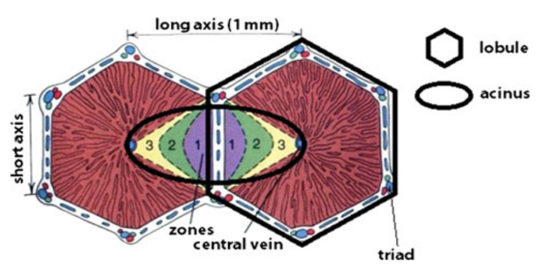

Figure 1: Structure of liver acinus and distribution of the three zones. Diagram from Godoy et al. [9]

.

1.2.1 In Vitro Model

Apart from animal models, recent years have seen rapid development of more sophisticated 3D in vitro cell culture models, including spheroid, organoid, scaffold, organ-on- a-chip and 3D bioprinting [6].

The spheroid cultuyre system has been commonly used to investigate hepatotoxicity. (ref?) As opposed to the traditional 2D monolayer cell culture, spheroid culture provides a simple solution to capture spatial gradients of oxygen, drug, nutrients or signalling molecules, because cells in central and peripheral parts of the spheroid have different exposure to the culture medium. (ref?)

Organ-on-a-chip, or microphysiological system (MPS) is another common but more sophisticated 3D in vitro culture model. It utilizes microfluidic devices with specific design and electronic control to simulate the microenvironment and important physi- ological features of organs. MPS for liver has been relatively well developed, and it is widely used in the pharmaceutical industry for pre-clinical screening. Figure 2 shows a typical design of the device [26]. While it has advantages, the MPS also has some limitations – it is complicated and time-consuming, taking up to 7 days to set up before drug intake [26]. Despite efforts to increase the throughput, it remains challenging to detect and interpret the trial results of liver MPS.

8

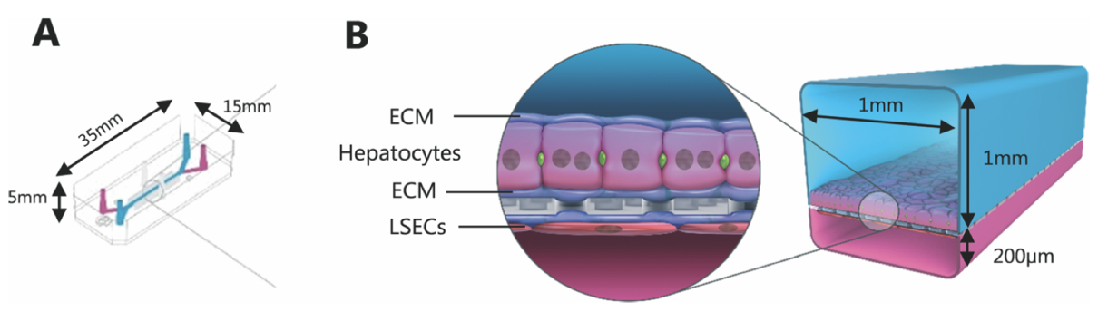

Figure 2: Deisgn of a liver MPS. (A) Dimensions of the MPS; (B) two cell types in the MPS: hepatocypte and liver sinusoidal endothelial cell (LSEC). The interface is coated with extracellular matrix (ECM). Culture media are flown across the cell layers. Diagram from Peel et al. [26]

.

1.2.2 In Silico Model

With the operational complexity of in vitro models in mind, researchers have developed *in silico* liver models to simulate in vitro liver models. Multiphysics simlution software such as COMSOL has been used to investigate the drug distribution in spheroid culture and guide the design of oxygen suppply of liver MPS [18, 16].

There are also more complicated in silico models aiming to directly model DILI in human. DILIsym® by Simulations Plus Inc. is a Quantitative Systems Toxicology software for human DILI that consists of a dozen interacting sub-modules, as from Figure 3 [1]. As opposed to the multiphyics simulations based on partial differential equations (PDE), DILIsym® is partitioned into the three liver zones each with its set of ordinary differential equations (ODE).

1.3 Systems Model of Drug-Induced Liver Injury (SysDILI)

Systems Model of Drug-Induced Liver Injury (SysDILI) is the in Silico DILI model presented in this thesis. Important features of SysDILI are summarised below.

• Modular: as from Figure 4, SysDILI consists of four interacting submodels, in the same spirit as the aforementioned DILIsym®. Each submodel was developed and tested independently, so they can be freely assembled. It is also handy to

9

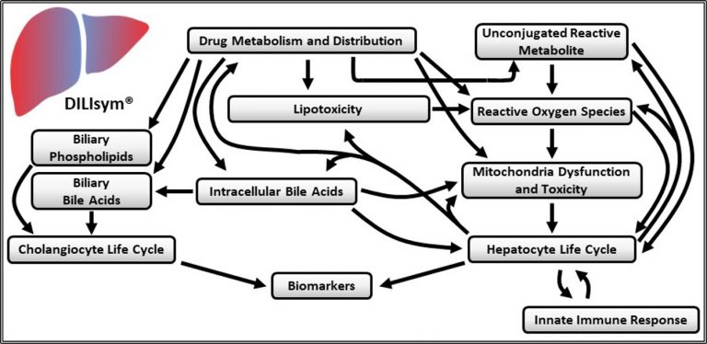

Figure 3: Structure of submodels in DILIsym®. Diagram from DILIsym® website [1] .

add new submodels such as glycolysis without changing the existing ones.

* Continuous Spatiotemporal Gradients: the gradients in each submodel are spatially continuous with no artificial zonation, in the same spirit as the aforemen- tioned multiphysics simulations. Also, the temporal dynamics for each gradient was modelled, not just the equilibrium states.
* Continuum of Domains: no individual hepatocyte or blood cell in SysDILI. Each domain was modelled as continuum.
* Mitochondrial Toxicity: out of the various DILI mechanisms mentioned above, SysDILI currently focuses on mitochondrial toxicity (reasons in Discussion sec- tion).
* Dry Lab: no experiments have been conducted so far. SysDILI was constructed entirely from existing data and known results.
* Flexible and Customisable: SysDILI currently models a sinusoid functional unit of human liver, but it can be readily adapted to MPS by changing the shapes of domains and the boundary conditions, because all the model parameters have been estimated and no gradient data was enforced during model construction.
* Aim to Be Mechanistic: the entire process was modelled whenever possible, including the changes in intermediate variables and temporal dynamics. Black

10

box models were only used when mechanistic modelling is challenging.

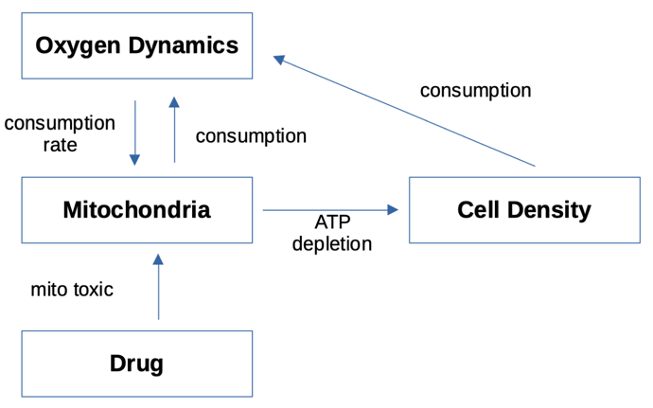

Figure 4: Schematic diagram of SysDILI

The ultimate goal of The SysDILI software/algorithm (idk what exactly it is) aims to to predict the DILI based on the provided drug mechanism and dose-response curve.(ref?). Meanwhile, instead of merely giving a score of toxicity, SysDILI was designed to preserve as much mechanistic and spatiotemporal information as possible. The extra information can be compared against physiological data for validation and might even reveal extra insights. With the flexibility, SysDILI can be used to guide the design of MPS and interpret the results.